Name: Marko Ćećez
E-mail: marko.cecez@unmo.ba
Institution: Dzemal Bijedic University of Mostar
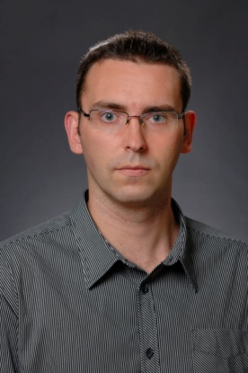 | Marko Ćećez holds master's degree in civil engineering and currently is Senior assistant for scientific field "Building materials" and "Construction organization and technology" (from 2015) at Faculty of Civil Engineering, "Džemal Bijedić" University of Mostar (UNMO).  Marko is PhD student at UNMO Polytechnic doctoral studies, and currently works on his PhD thesis Mortar and concrete with the addition of industrial by-products. Research interests includes building materials, concrete, concrete with waste products, sustainable construction etc. Marko has completed several training programmes, among which can be emphasized: Training programme – Energy efficiency and management in industry and Buildings, Ankara, Turkey (2016).  He has published 27 research papers in international conferences, 5 papers published in journals and he is an author of 1 paper in edited volume. Marko has actively participated in 8 national research projects, 1 COST Action and 1 completed Erasmus+ project.
References (max. 5 relevant references)
1. Creating the Network of Knowledge Labs for Sustainable and Resilient Environments (KLABS) Proj. No. 561675-EPP-1-2015-1-XK-EPPKA2-CBHE-JP (2015-2018). Team member from UNMO, performing various tasks including financial and technical reporitng.
2. Healthy URBan Environment: Developing Higher Education in Architecture and Construction in Bosnia and Herzegovina (HURBE) Proj. No. 598503-EPP-1-2018-1-IT-EPPKA2-CBHE-JP (2018-2021). Team member from UNMO, performing various tasks including financial and technical reporitng.
3. Promoting academia-industry alliances for R&D through collaborative and open innovation platform (All4R&D) Proj. No. 598719-EPP-1-2018-1-MK-EPPKA2-CBHE-JP (2018-2021). Team member from UNMO, performing various tasks including financial and technical reporitng.
4. Žujo V., Car-Pušić D., Žileska-Pančovska V., Ćećez M.: Time and Cost Interdependence in Water Supply System Construction Projects, Technological and Economic Development of Economy, 2015, DOI: 10.3846/20294913.2015.1071292
5. Šahinagić – Isović M., Špago S., Ćećez M., Ćatović F.: Characteristics of polypropylene and polyethylene pipes for drainage of precipitation waters, 3. International Conference New Technologies NT 2016, Mostar, Bosnia and Herzegovina, pp. 277 – 284. ISSN 2303-5668
This project has been funded with support from the European Commission. This publication reflects the views only of the author, and the Commission cannot be held responsible for any use which may be made of the information contained therein.

